SPECIAL TECHNICAL OPERATIONS PLANNER COURSE (STOPC)
Course Location: Ft Sill and various off-site locations as needed.
Course Length: 1 Week

Prerequisites:
TS/SCI/TK security clearance and read-on access
Rank: 1LT – COL, WO1 – CW5, SSG- SGM
Assigned to a STO billet at DIV, CORPS, ASCC or ARCYBER

Course Overview:
Emphasis is on U.S. Army and Joint doctrine, tactics, techniques, and procedures (TTP) to prepare Officers, Warrant Officers, NCOs, Civilians and select Contractors to participate in STO coordination, planning and execution at the tactical and operational levels in a variety of U.S. Army and Joint organizations.

Course dates:
Class | Start Date | End Date | Location
701 | 2015-10-26 | 2015-10-30 | COLORADO SPRINGS
702 | 2015-11-16 | 2015-11-20 | FT BRAGG
001 | 2015-12-07 | 2015-12-11 | FT SILL
703 | 2016-01-25 | 2016-01-29 | YONGSAN
704 | 2016-02-22 | 2016-02-26 | JBLM
002 | 2016-03-07 | 2016-03-11 | FT SILL
003 | 2016-04-18 | 2016-04-22 | FT SILL
705 | 2016-05-16 | 2016-05-20 | FT HOOD
706 | 2016-06-13 | 2016-06-17 | FT SHAFTER
004 | 2016-07-18 | 2016-07-22 | FT SILL
708 | 2016-09-12 | 2016-09-16 | GRAFENWOEHR
700 | 2016-09-19 | 2016-09-23 | FT SILL

Enrollment:
Through ATRRS under school code 061. Course: 2E-F280/250-F69 (RP)
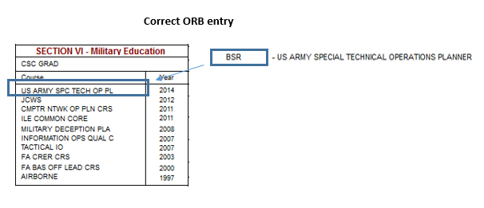
NOTE: Skill Identifiers V8 (STO Planner) and V9 (STO Chief) are NOT awarded solely for course completion. Graduates must also successfully serve in a STO billet and submit a request to HQDA, ODCS, G-3/5/7, DAMO ODG for award. More information can be found in DA PAM 611-21.

