SEE Carnegie’s “Tunisia Monitor,” among others, for deeper analyses of Tunisia’s “fragile” political transition from the Arab Spring: https://carnegieendowment.org/specialprojects/TunisiaMonitor/

More Schools and Fewer Tanks for the Mideast
The U.S. should send more soft power and less hard power to the region.
By Thomas L. Friedman
Opinion Columnist
Jan. 22, 2019
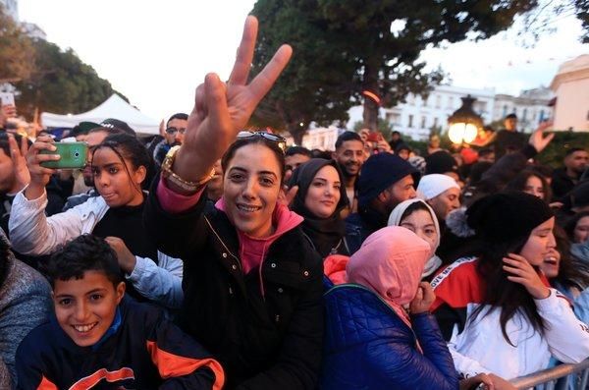
Tunisians last week celebrated the anniversary of their 2011 revolution. CreditCreditYassine Gaidi/Anadolu Agency, via Getty Images
President Trump’s sudden announcement that he’s pulling U.S. troops out of Syria and shrinking their number in Afghanistan has prompted a new debate about American ground forces in the Middle East and whether keeping them there is vital or not. I’m asking myself the same question. To answer that question, though, I need to start with another question:
Why is it that the one Arab Spring country that managed to make a relatively peaceful transition from dictatorship to a constitutional democracy — with full empowerment for its women — is the country we’ve had the least to do with and where we’ve never sent soldiers to fight and die? It’s called Tunisia.
Yes, Tunisia, the only Middle East country to achieve the ends that we so badly desired for Iraq, Syria, Egypt, Libya, Yemen and Afghanistan, did so after having hosted more U.S. Peace Corps workers over the last 50 years than U.S. military advisers and after having received only about $1 billion in U.S. aid (and three loan guarantees) since its 2010-11 democracy revolution.
By comparison, the U.S. is now spending about $45 billion a year in Afghanistan — after 17 years of trying to transform it into a pluralistic democracy. That is an insane contrast. Especially when you consider that Tunisia’s self-propelled democracy is such an important model for the region, but an increasingly frail one.
It’s threatened by labor strikes, the spillover of instability from Libya, a slowing economy that can’t produce enough jobs or income for its educated young people, a 2016 International Monetary Fund loan that restricts the government from hiring, all causing stresses among the key players in its power-sharing deal involving trade unionists, Islamists, old-regime types and new democrats. For now, Tunisia is holding together, but it could sure use one week’s worth of what we spend in Afghanistan.
Why could Tunisia transition to democracy when others couldn’t? It starts with its founding father, Habib Bourguiba, Tunisia’s leader from independence, in 1956, to 1987. Though he was a president-for-life like other Arab autocrats, Bourguiba was unique in other ways: He kept his army very small and did not waste four decades trying to destroy Israel; he was actually a lonely voice calling for coexistence. He educated and empowered Tunisian women and allowed relatively strong civil society groups to emerge — trade unions, lawyers’ syndicates, women’s groups, who were vital to toppling Bourguiba’s tyrannical successor and forging a new Constitution with Tunisia’s Islamic movement. Tunisia was also blessed by having little oil, so it had to invest in its people’s education.
Tunisia, in short, had the cultural underpinnings to sustain a democratic revolution. But political and cultural transformations move at different speeds. The U.S. (myself included) wanted to rush the necessary cultural transformation of Afghanistan and Iraq, but as Peter Drucker once noted, “Culture eats strategy for breakfast.” That fact — plus our own incompetence and their corruption — has eaten alive the U.S. democracy efforts in Iraq and Afghanistan.
All of this shapes how I think about Trump’s abrupt order to withdraw from Syria and desire to get out of Afghanistan. I think he is right on Afghanistan. We’ve defeated Al Qaeda there; it’s time for us to negotiate with the Taliban and Pakistan the best phased exit we can — and take as many people who worked for us as we can. Afghanistan has hard countries around it — Russia, Pakistan, India, China and Iran — and they have the ability to contain and manage the disorder there. We gave at the office.

I’d keep our special forces in Syria, though, but not because we’ve yet to defeat ISIS. ISIS is a direct byproduct of the wider regional struggle between Sunnis and Shiites, led by Saudi Arabia and Iran. ISIS arose as an extreme Sunni response to the extreme efforts by Iran and pro-Iranian Shiite militias in Iraq and Syria to ethnically cleanse and strip power from Sunnis in Iraq and Syria. As long as Iran pursues that strategy, there will be an ISIS in some form or other.
That’s why the only peace process that could have a stabilizing effect across the Middle East today is not between Israelis and Palestinians — but between Iran and Saudi Arabia.
What the small, not-all-that-costly U.S. force in Syria does that is most important is prevent the awful there from becoming the truly disastrous in a couple ways. It does so in part by protecting the Kurds and moderate Sunnis from the murderous Syrian government and Turkey. The mainstream Syrian and Iraqi Kurds have been, for the most part, forces for decency and Western values in that corner of the world. One day we might build on their islands of decency; they’re worth preserving.
Our forces also help stabilize northeastern Syria, making it less likely that another huge wave of refugees will emerge from there that could further destabilize Lebanon and Jordan and create nativist backlashes in the European Union like the earlier wave did. To me, the European Union is the other United States of the world, and we and NATO have a vital interest in protecting the E.U. from being fractured over a fight over the influx of Mideast refugees.
Finally, I’d take $2 billion of the $45 billion we’d save from getting out of Afghanistan and invest it regionally in all the cultural changes that made Tunisia unique — across the whole Arab world. I’d give huge aid to the American University in Cairo, the American University in Beirut, the American University of Iraq, Sulaimani, and the American University of Afghanistan.
And I’d massively expand the scholarship program we once ran by which top Arab public school students were eligible for a U.S.-funded scholarship to any U.S.-style liberal arts college in Lebanon or anywhere else in the region.
I’d also massively expand student visas and scholarships — especially for Arab women — for study in America. And I’d offer 5,000 scholarships for Iranians to come to America to get graduate degrees in science, engineering or medicine, with visas available in Dubai. That line would be so long! Nothing would embarrass the Iranian regime more.
And I’d give Tunisia a $1 billion interest-free loan and quadruple the size of the Tunisian American Enterprise Fund that promotes start-ups there.
The other $43 billion I’d spend on new infrastructure in America.
Since 9/11, we’ve relied almost entirely on hard power. Some was needed, some is still needed, but most of it failed. It’s time we tried more soft power. It’s time we focused on giving more Arabs and Iranians access to the ingredients that enabled Tunisia to transform itself by itself into a democracy without a single U.S. war fighter.
Yes, it will take a long time. But there was never a shortcut, and the approach we tried with the Pentagon in the lead has only led to multiple dead ends.

