CAC Commander’s Memorial Day Message 2015

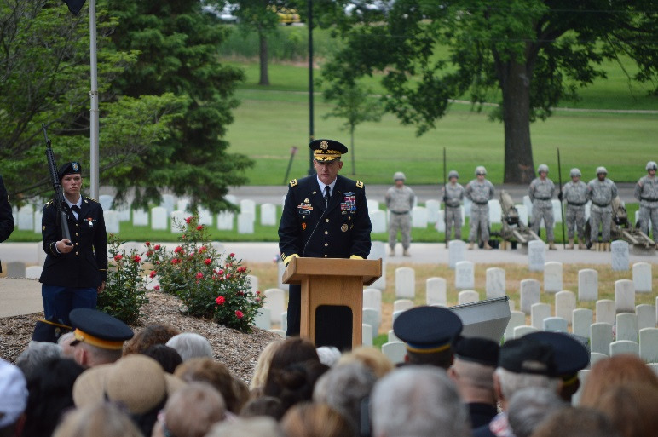
Memorial Day is a day we remember and honor America’s fallen Warriors – courageous men and women who died in military service. Since 1868, this day has served as a tribute to our fallen with families, veterans and patriotic Americans placing flowers on the graves of our nation’s heroes. Originally called Decoration Day, Memorial Day was a day set aside to remember those who have died in our nation’s service.

They did not fight to conquer the world, but to liberate it. Each of them raised their right hand to serve something greater than themselves, an ideal, and a cause or just simply for the love of country. However, they all shared one common thread: they believed that the principles of life and liberty for all people were worth their sacrifice.

We honor the selfless actions of these brave men and women who thought themselves ordinary, but rose to meet seemingly impossible expectations to keep hope and freedom alive, not just in America, but throughout the world. They were real people – sons and daughters, mothers and fathers, brothers and sisters, wives and husbands. They were strong and vibrant. They loved and were loved. And they are missed.

Today we must reflect and renew our commitment to the fallen. Our commitment to live our own lives as fully as possible, and to always be willing and able to give back to our families, our communities, and our nation. In doing these thing we honor them and their legacy will live on.

As this Memorial Day also marks the start of summer season activities, we must also ensure a safe and enjoyable weekend. Although we cannot eliminate all of the hazards associated with this time of year, we can minimize their effects, ensuring risk management is integrated into all that we do. Whether taking a long trip, barbecuing, participating in recreational activities, or performing chores around your home, make sure to include safety measures in your activities. Let’s all do our part to make this a safe and enjoyable holiday.

LTG Robert B. Brown
Commanding General
US Army Combined Arms Center and Fort Leavenworth.

